**OUTPUT OF CRAMER’s RULE**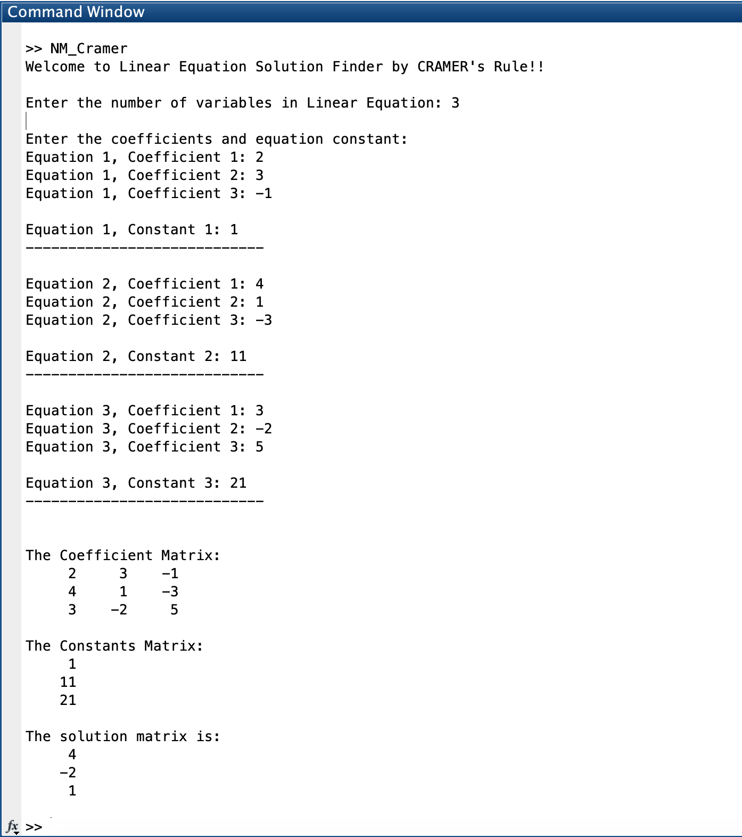

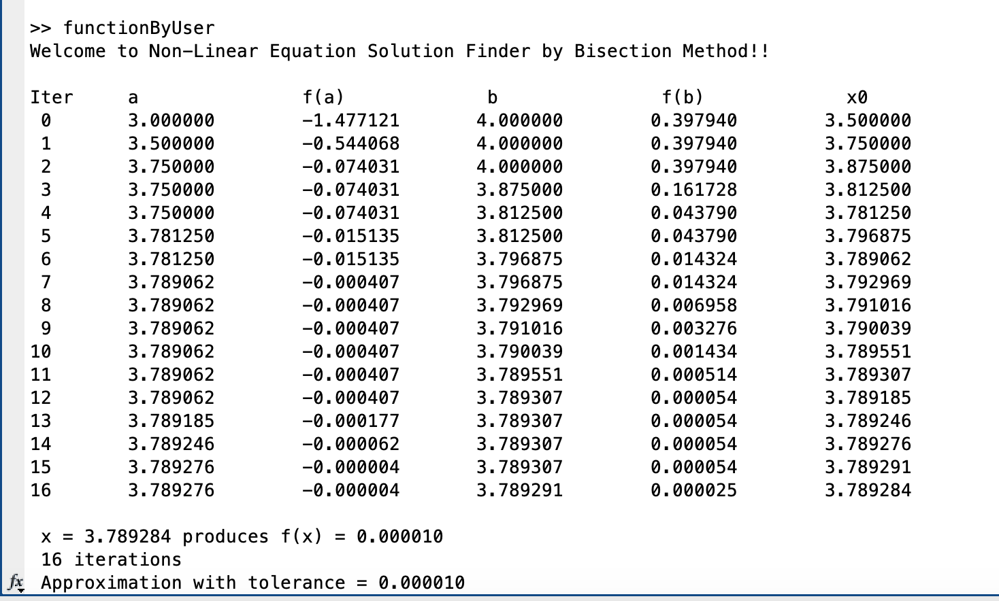**OUTPUT OF BISECTION METHOD**

**For function: 2x – log(x) – 7 from [3,4]**

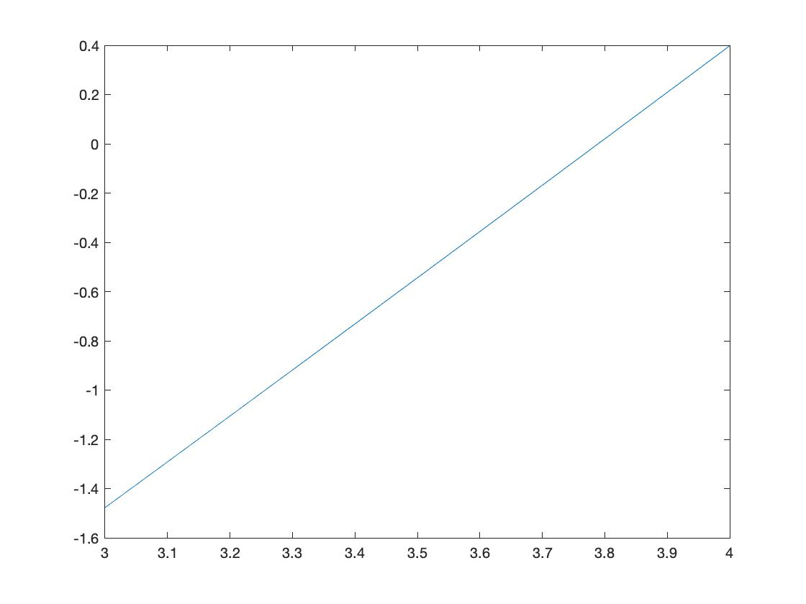

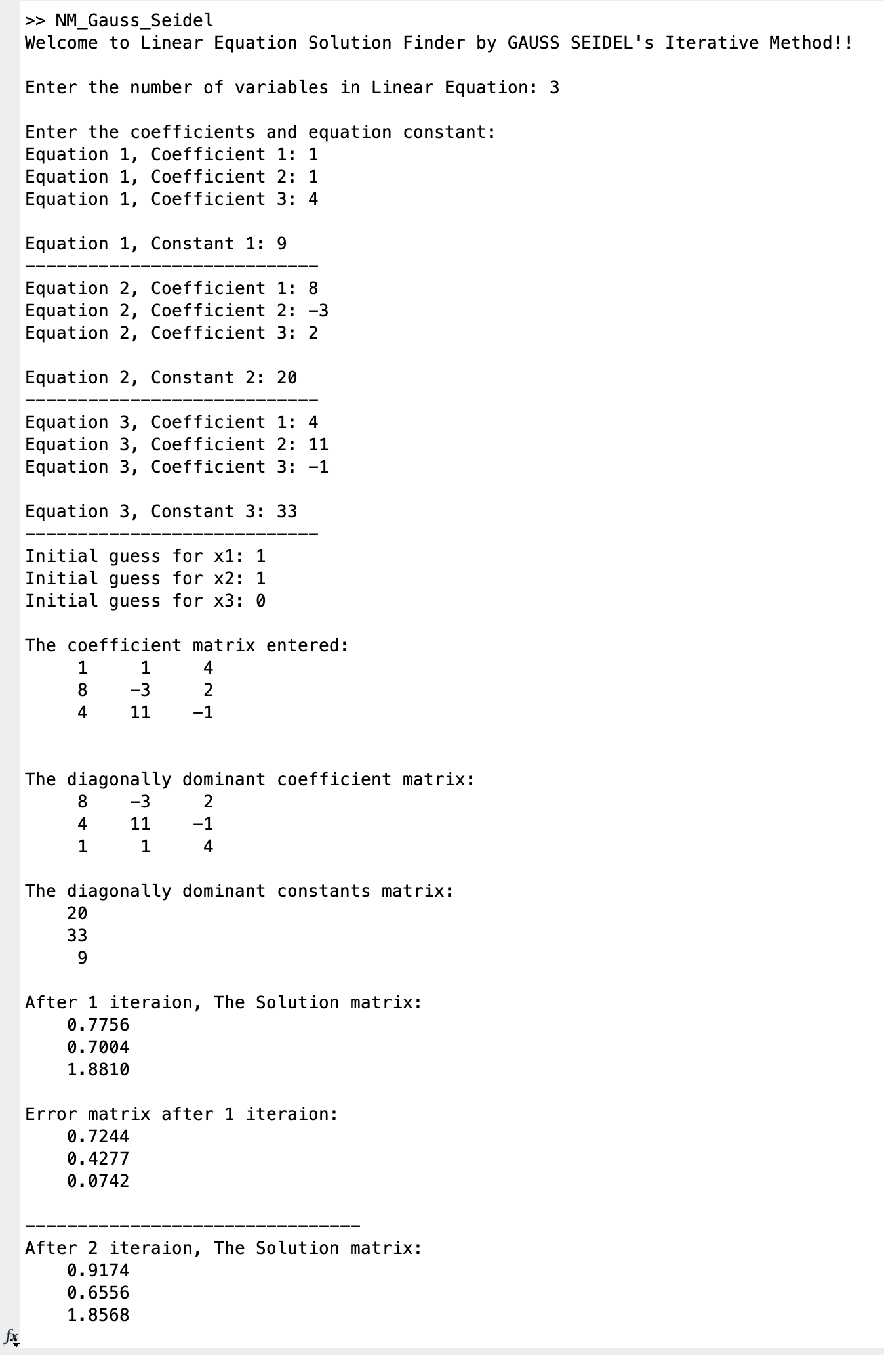**OUTPUT OF GAUSS SEIDEL METHOD**

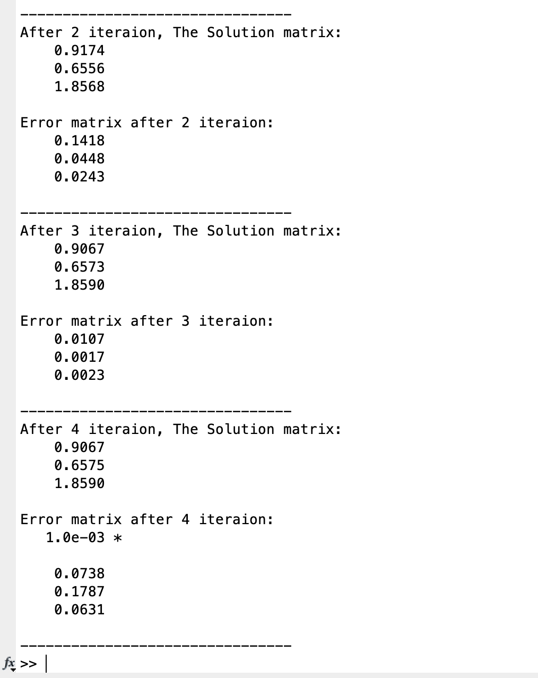



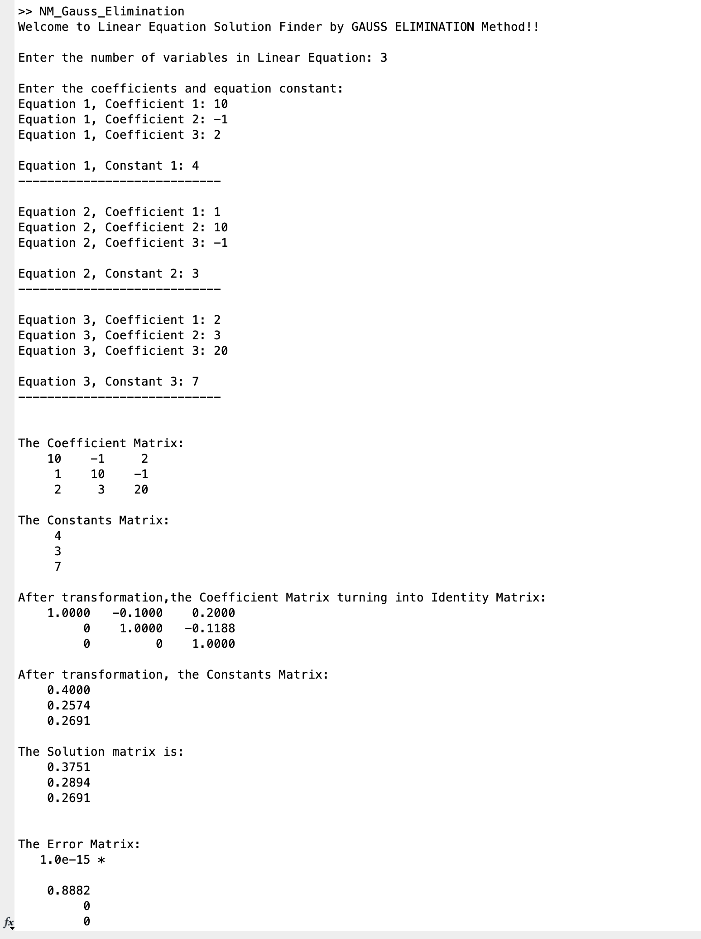**OUTPUT OF GAUSS ELIMINATION METHOD**

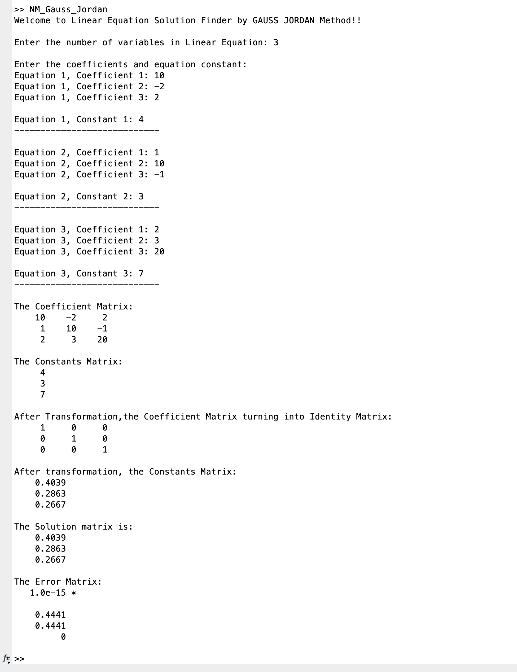**OUTPUT OF GAUSS JORDAN METHOD**

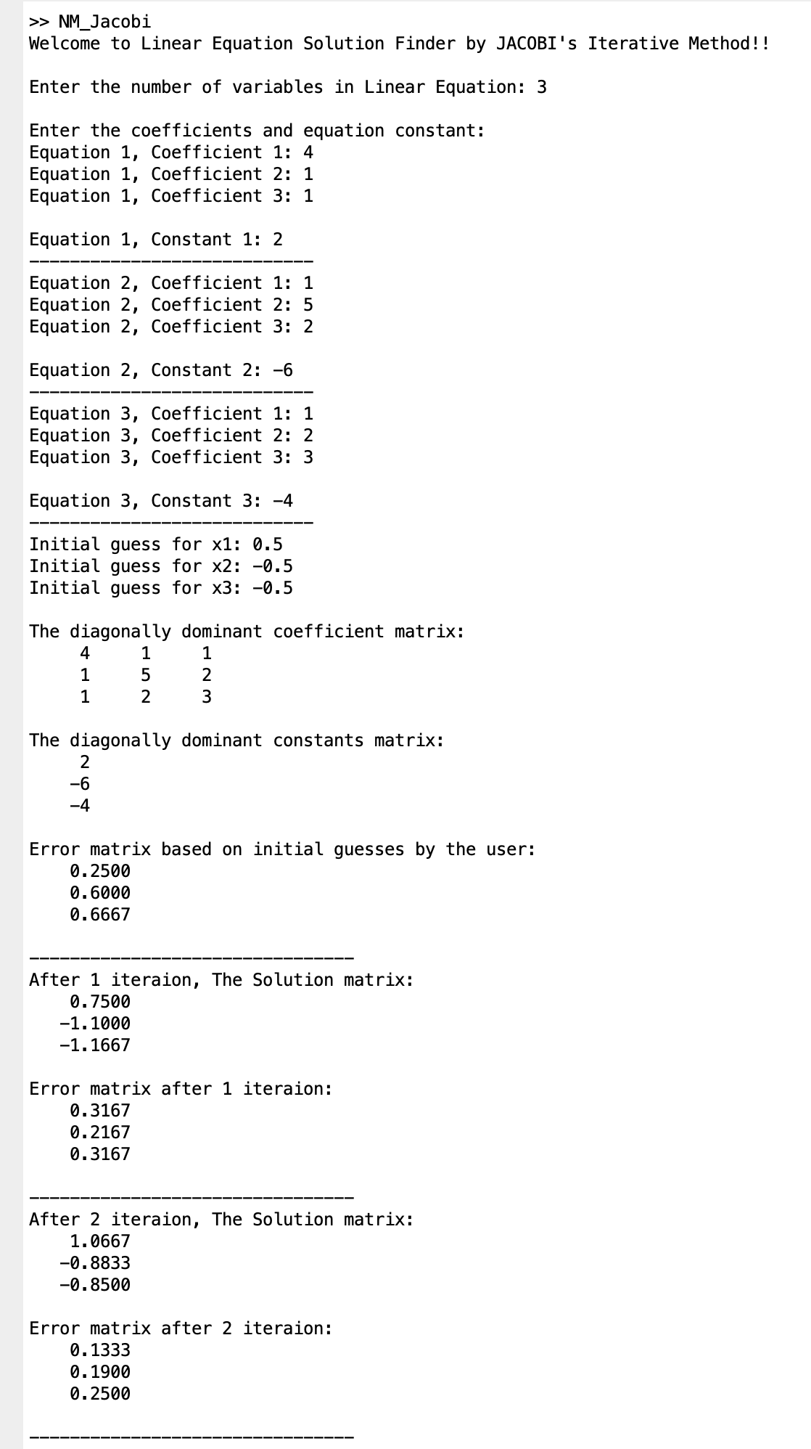**OUTPUT OF JACOBI’S MATRIX METHOD**

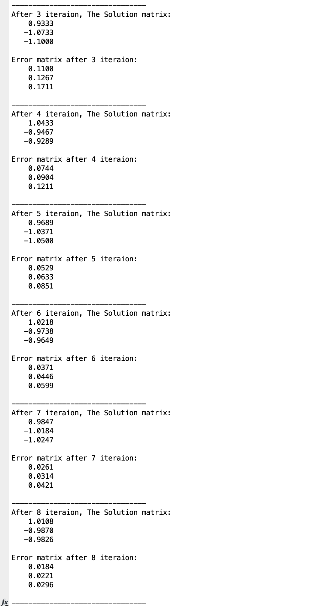

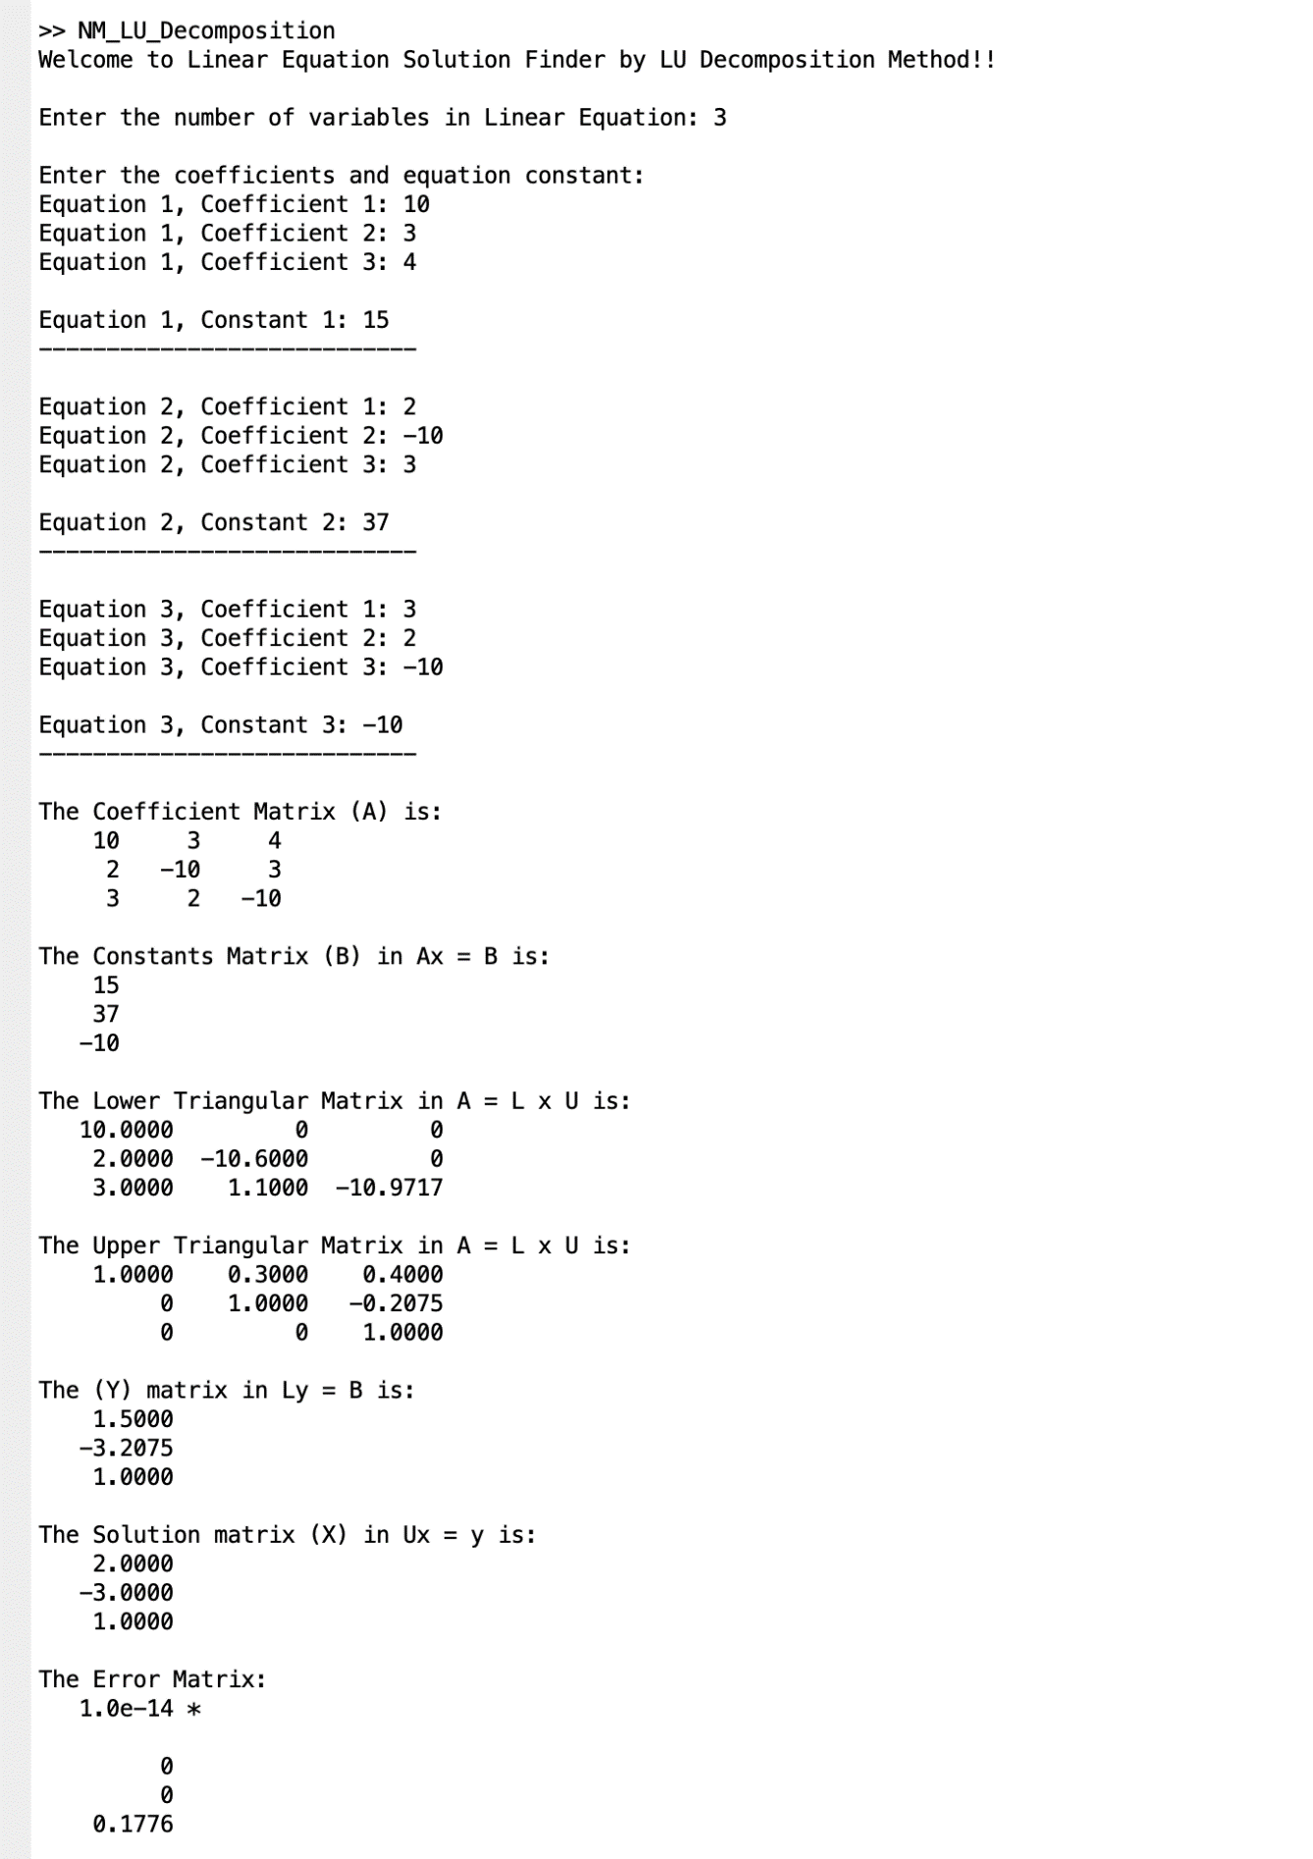**OUTPUT OF LU DECOMPOSITION METHOD**

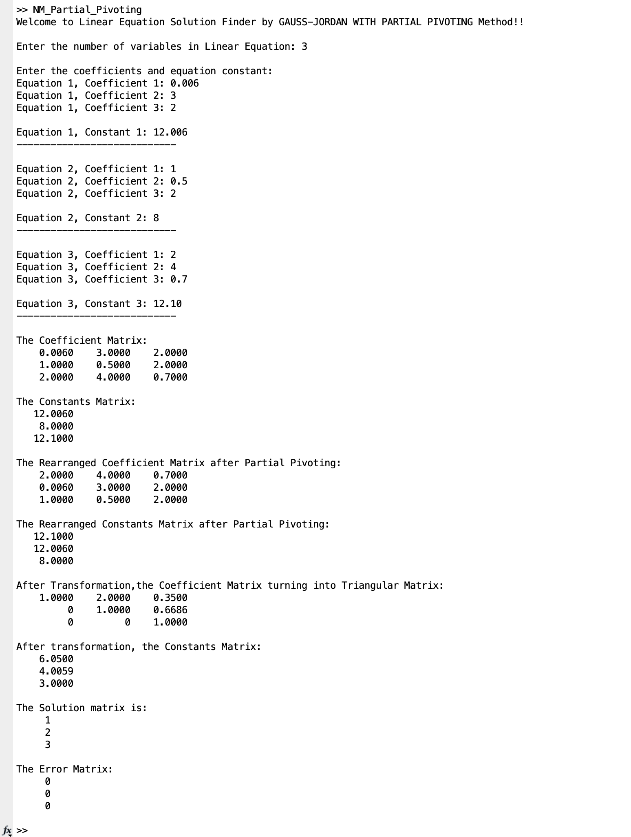**OUTPUT OF GAUSS ELIMINATION WITH PARTIAL PIVOTING METHOD**

**OUTPUT OF REGULA FALSI ITERATIVE METHOD**

**For functions**

1. **2x – log(x) - 7 from [3,4]**
2. **xln(x) -1 from [1,2]**

